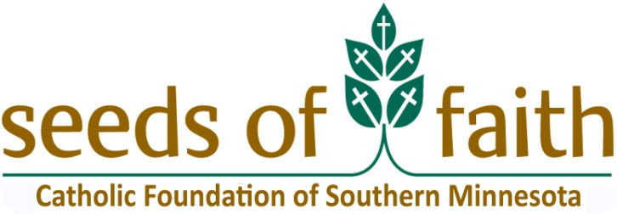

February 14, 2022

Dear Pastors and School Administrators:

It is with great pleasure that I announce that $139,800 in endowment earnings from the ***Seeds of Faith Catholic School Tuition Assistance Fund*** is available for need-based assistance for the 2022-2023 school year! Last year, 196 families received tuition assistance totaling $133,600.

The distribution of funds will follow the case statement adopted for the endowment fund in the ***Seeds of Faith*** campaign. It promised:

***“…The diocese will establish a $2,000,000 endowment fund designated to provide tuition assistance to parents who seek a Catholic education for their children and who demonstrate a financial need. This endowment also will respond to a special need to provide tuition funding for the newly arrived immigrants in our diocese.”***

By now, each school should have received the applications for the 2022-2023 school year. If you need additional forms, please email Ryan Henry at [rhenry@catholicfsmn.org](mailto:rhenry@catholicfsmn.org) or visit [www.catholicfsmn.org/granting](http://www.catholicfsmn.org/granting).

Again, this year we have funds available for Hispanic families with financial need. The ***Rothwell*** ***Endowments*** earnings allow us to distribute $17,000 for the 2022-2023 school year. The application and the process are the same for ***Seeds of Faith-Tuition Assistance*** funds and ***Rothwell*** funds.

It is important that families in the schools and parishes are aware that need-based financial assistance is available. A message published in newsletters, bulletins, email updates, etc. is recommended. These are great ways to let parents know about the availability of need-based funds which might, in turn, hopefully increase enrollment for your school.

In all announcements, it is important to emphasize that ***Seeds of Faith-Tuition Assistance*** is need-based and that the funds are available only to families who demonstrate financial need. This is not an academic scholarship fund.

Applications must be completed by parents and submitted to the pastor and/or school administrator. **Please note that *Section B* and *Section E* must be completed by the pastor and/or school administrator.** Funds are distributed based upon the specific information on the application form. Please make sure that all of the required paperwork is included with the form. A checklist appears on the last page of the application form to help parents, pastors, and administrators make sure that the application is complete. **Please note: incomplete applications will not be accepted and will be returned.**

Once the pastor and/or school administrator has completed the required sections, please send the form to Catholic Foundation of Southern Minnesota (PO Box 30098, Winona, MN 55987). Please note the deadline for all applications is **May 13, 2022**; all applications must be postmarked on or before that date.

In the days following **May 13, 2022**, school administrators will receive a list of ***Seeds of Faith-Tuition Assistance*** tuition assistance applicants to review for their school and respond with the applicant’s Gross Tuition, which is the applicant's total tuition bill minus any other tuition assistance such as scholarships or grants. This step is required, and applications from your school will not be considered until this step is complete. The deadline to complete this step is **June 1, 2022**.

Following **June 1, 2022**, applications will be reviewed by the grant committee that will make recommendations for the award of tuition assistance funds. In July, the Catholic Foundation of Southern Minnesota will inform recipients of the committee’s decision and will send award checks with corresponding recipient lists to each school. Tuition assistance funds can be used only for the 2022-2023 academic year; they may not be used to pay overdue tuition.

Please direct any questions you may have to Ryan Henry at [rhenry@catholicfsmn.org](mailto:rhenry@catholicfsmn.org) or 507-858-1275, or Monica Herman at [mherman@catholicfsmn.org](mailto:mherman@catholicfsmn.org) or 507-858-1276.

Thank you for helping the families of your parish and school share in the generosity of the many thousands of Catholics who made gifts to the ***Seeds of Faith-Tuition Assistance Campaign.*** Through this assistance, all of us are reminded to be stewards of God’s gifts and to make them available to accomplish the plan that God has for all of us.

In Christ,



Monica Herman

Executive Director

Catholic Foundation of Southern Minnesota

**Important Dates:**

* **Application Due Date = Friday, May 13, 2022**
* **School Administrator Applicant Tuition Review & Response to the Catholic Foundation of Southern Minnesota Due Date = Wednesday, June 1, 2022**
* **Grant Committee in session = June 2022**
* **Letters to Applicants and Funds to Schools sent = July 2022**

**PS: Please let us know if you have families that are granted an award, but later decline to attend your school, so we can reallocate their award to another family. Any award money sent will need to be returned by the school.**